HOW OCEAN DEPTH IS MEASURED BY SOUNDING

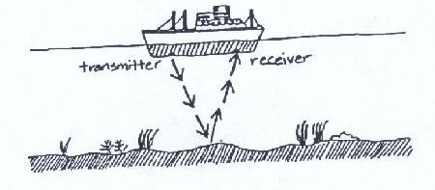
Much of the oceans topography has been mapped by the use of devices such as sounding. In this method sound is sent from a ship's transmitter to the ocean's bottom at an angle. It bounces back to the ship at the same angle and is picked up by a receiver on the same ship. We know that the speed of sound is about 1534 meters per second (1534 m/s). By using this information and applying the following formula, ocean depth can be measured and mapped.

The formula for measuring ocean depth:

D = 1/2 T x V
D = depth
T = time
V = speed or velocity of sound in water (1534 meters per second)

Using this formula, find the depths of the ocean in the given locations and plot the depths on the graph top make a topographical map.
In a certain area of the ocean, a ship traveling in a straight line receives the following sonar signals:

Location A. 1st signal...........1 second
Location B. 2nd signal...........2 seconds
Location C. 3rd signal...........4 seconds
Location D. 4th signal...........8 seconds
Location E. 5th signal...........6 seconds
Location F. 6th signal...........4 seconds
Location G. 7th signal...........2 seconds
Location H. 8th signal...........2 seconds
Location I. 9th signal...........2 seconds
Location J. 10th signal...........1 second

Find the depth at each location.

A_______________ B_____________ C__________________

D_______________ E_____________ F__________________

G_______________ H_____________ I________________ J____________
Use the supplied graph and draw a map of this part of the ocean's floor (topography)

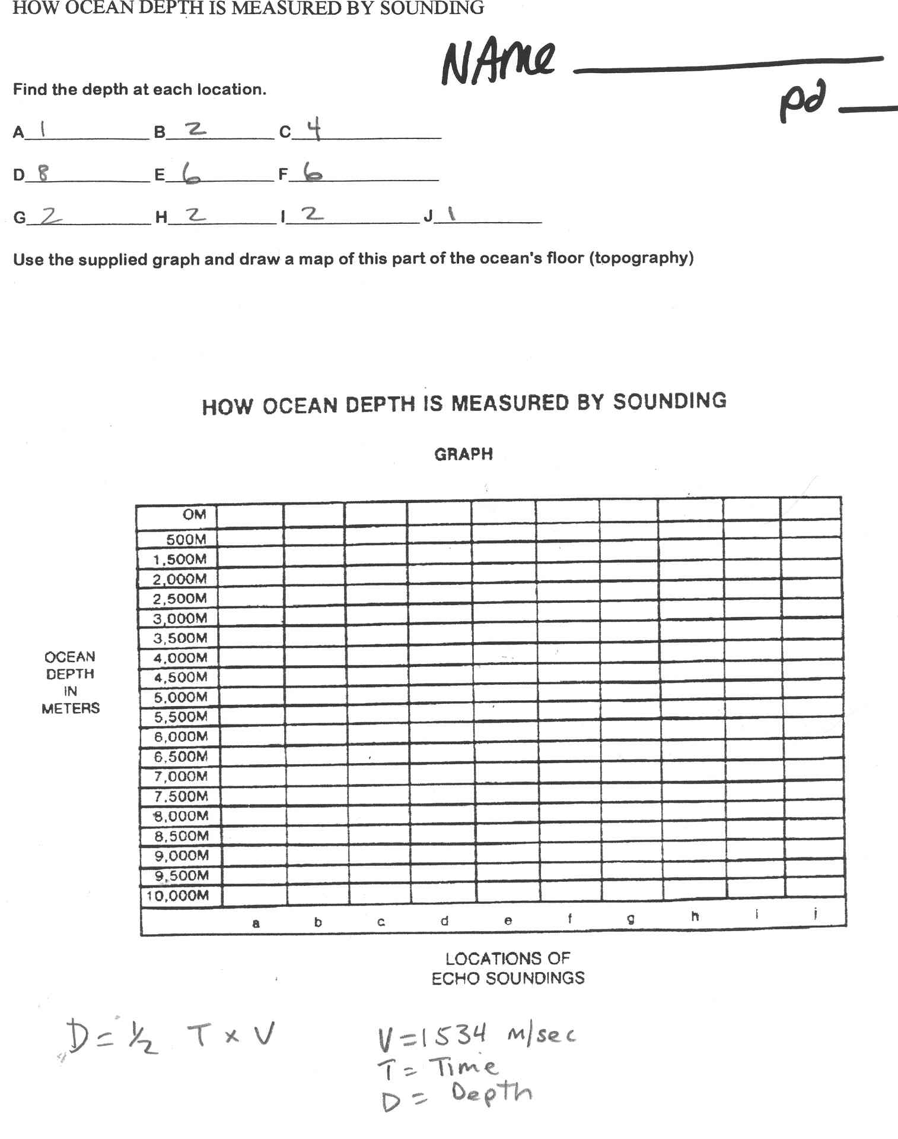

Making and Ocean Profile
Imagine you are the sonar crew working with the world famous oceanographer, Captain Jacques Yves Cousteau of the sailing ship Calypso. Your scientific mission is to chart the Atlantic sea floor along 39°N latitude. You set sail from Atlantic City, New Jersey and traverse the mighty ocean to your destination in Lisbon, Portugal. Along the way, you use your sophisticated sonar to probe the unseen depths below. You collect a wealth of data on the depth of the ocean floor, which is in the table on the next page. Now, you will use that data to create a graph and profile of the ocean bottom. Good luck, and may the seas be kind to you...
Set up Your Graph Paper
Take time to make sure that your graph paper is properly set up. A well-designed graph includes the following:
- A title that identifies your data
2. An x-axis and a y-axis
3. Axis labels including metric units
4. Well-chosen number scales along each axis
Here are some questions to help design your graph:
1. What data and label go along the x-axis?
2. What data and label go along the y-axis?
3. If we are plotting depth below the ocean surface, where should we put zero on the y-axis?
Plot Your Data
Plot each point in the data table on your graph. Once all of the points are plotted, connect the points with straight lines. This will give you a profile of the changing depth of the ocean as you travel along 39°N latitude in the Atlantic Ocean from west to east.
Analyze Your Data
Research ocean floor features in your textbook, in the library, on the Internet, or from your class notes. On your graph, identify and label the following features: Continent, Continental Shelf, Continental Slope, Abyssal Plain, Mid-Ocean Ridge, Island, and Seamount. Note that this traverse does not cross any Trenches.

Answer the Following:
1. What ocean floor structure occurs between 0 and 160 km east of New Jersey?
2. What ocean floor structure occurs between 160 and 1050 km east of New Jersey?
3. What ocean floor structure occurs between 1000 and 2000 km east of New Jersey?
4. What ocean floor structure occurs between 2000 and 3000 km east of New Jersey?
5. What is the scale of your x-axis? 1 unit =
6. What is the scale of your y-axis? 1 unit =

7. If you wanted to draw your profile to scale, the units and distances along both your x-axis and y-axis would have to be the same. Your profile as it is drawn now is exaggerated. To find the vertical exaggeration, divide your x-axis by your y-axis.
What is the exaggeration?
8. If you drew your profile to scale, about how long a sheet of paper would you need?

Atlantic Ocean Profile Data along 39°N Latitude
Sonar  Reading | Distance from  New Jersey (km) | Depth to  Ocean Floor (m)
1 | 0 | 0
2 | 160 | 165
3 | 200 | 1800
4 | 500 | 3500
5 | 800 | 4600
6 | 1050 | 5450
7 | 1450 | 5100
8 | 1800 | 5300
9 | 2000 | 5600
10 | 2300 | 4750
11 | 2400 | 3500
12 | 2600 | 3100
13 | 3000 | 4300
14 | 3200 | 3900
15 | 3450 | 3400
16 | 3550 | 2100
17 | 3600 | 1330
18 | 3700 | 1275
19 | 3950 | 1000
20 | 4000 | 0
21 | 4100 | 1800
22 | 4350 | 3650
23 | 4500 | 5100
24 | 5000 | 5000
25 | 5300 | 4200
26 | 5450 | 1800
27 | 5500 | 920
28 | 5600 | 180
29 | 5650 | 75
30 | 5700 | 0

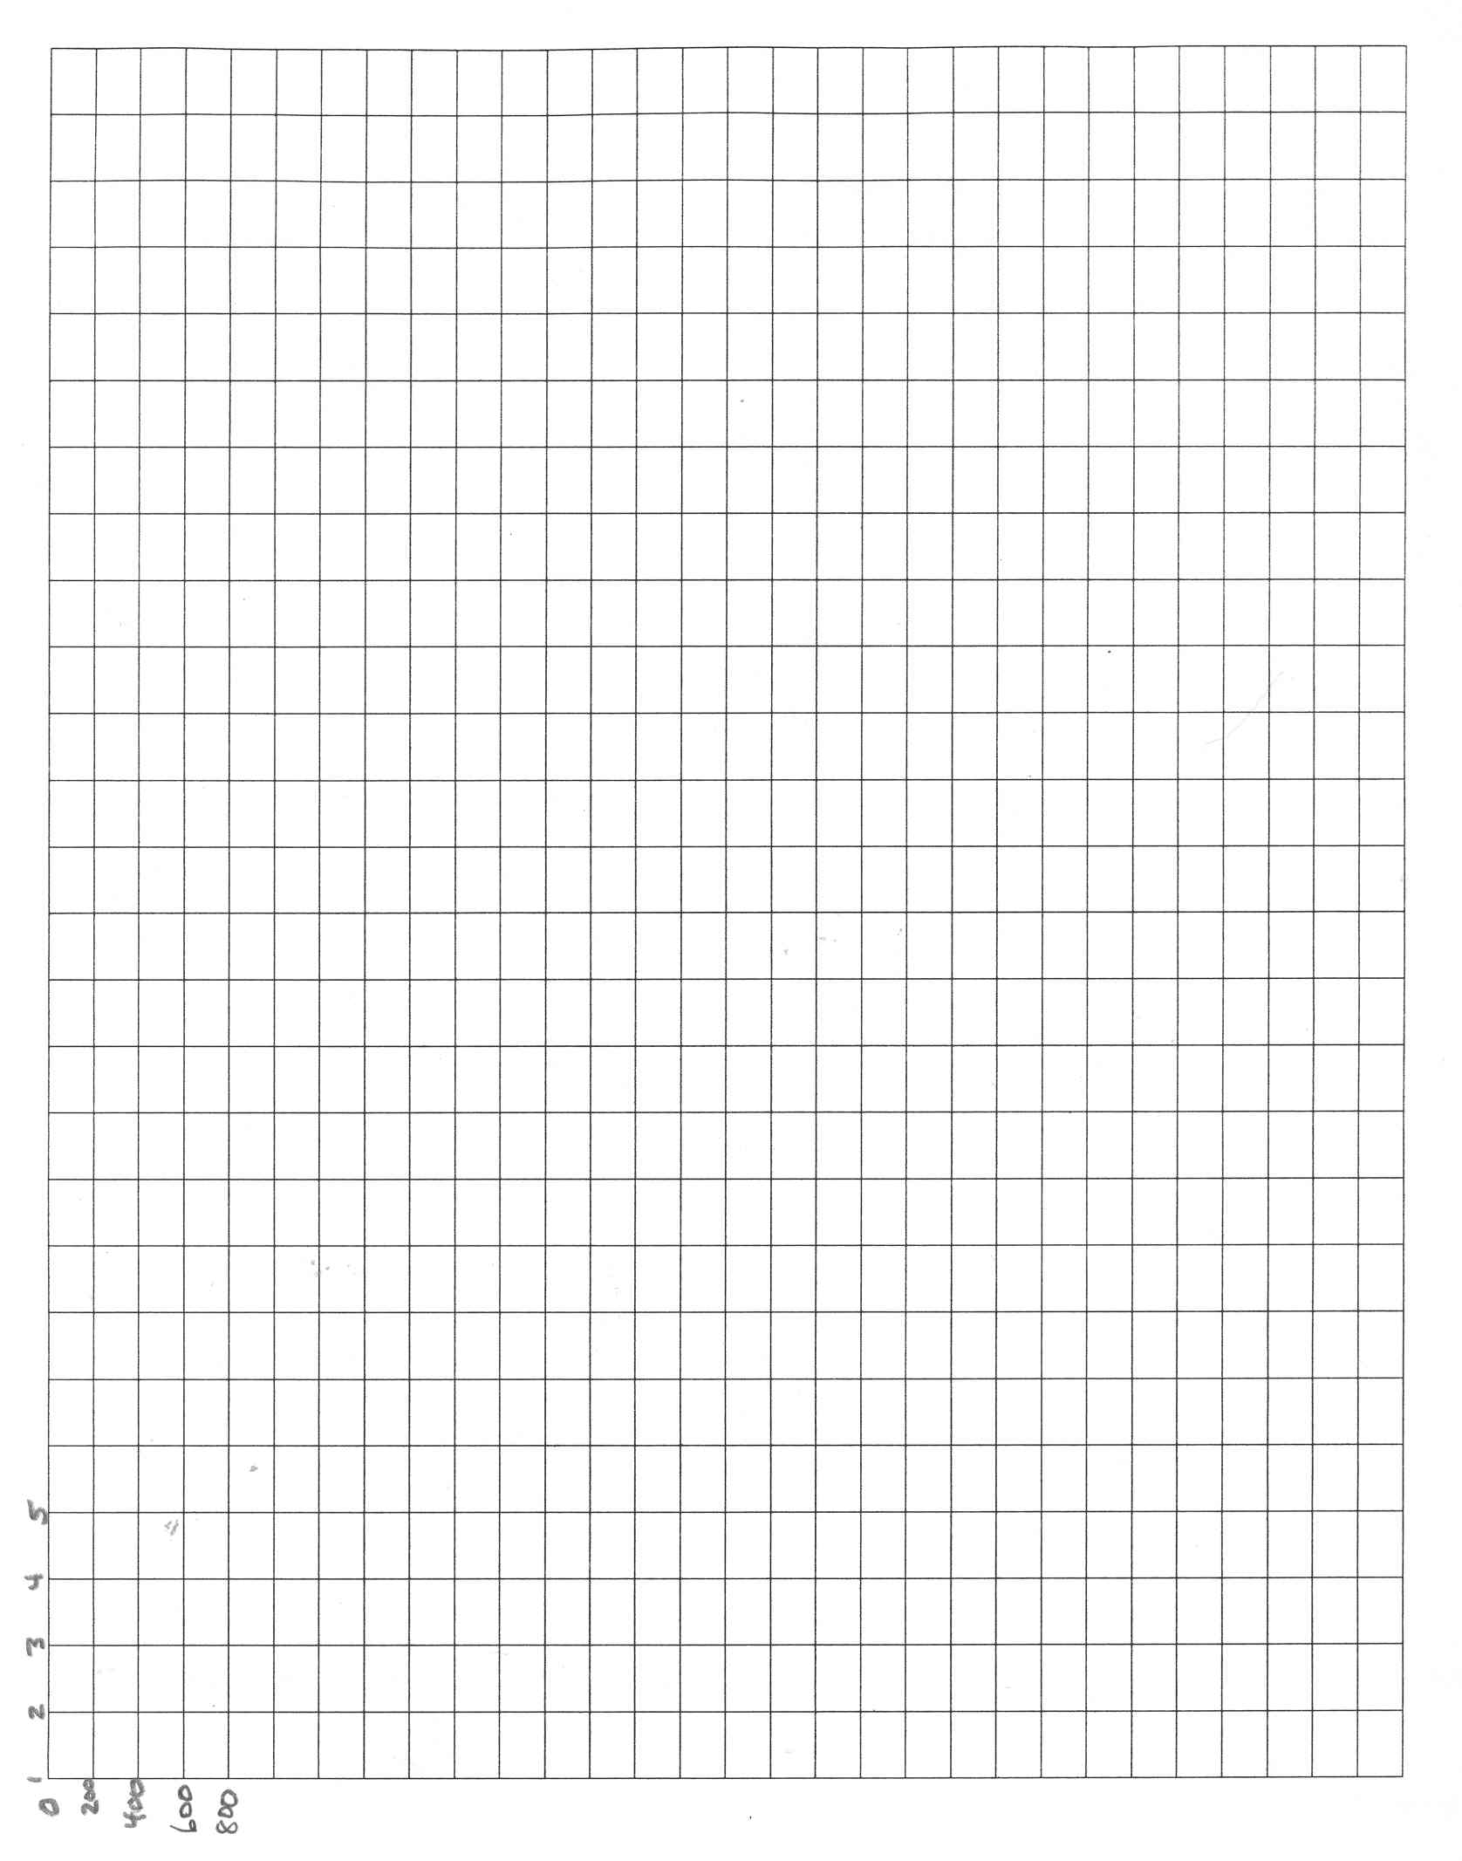

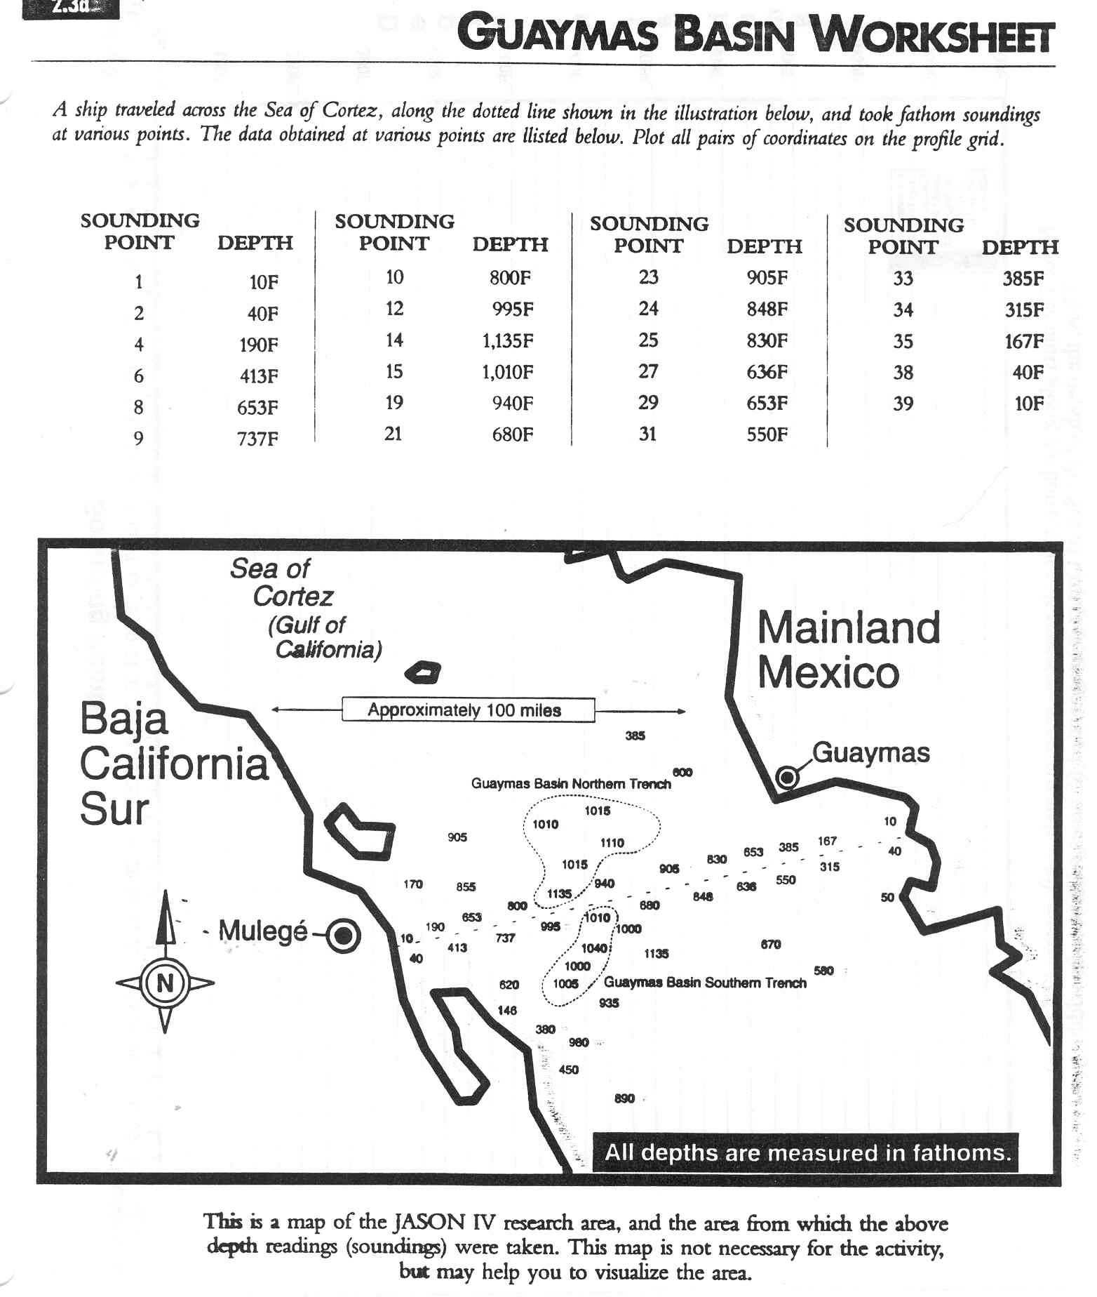

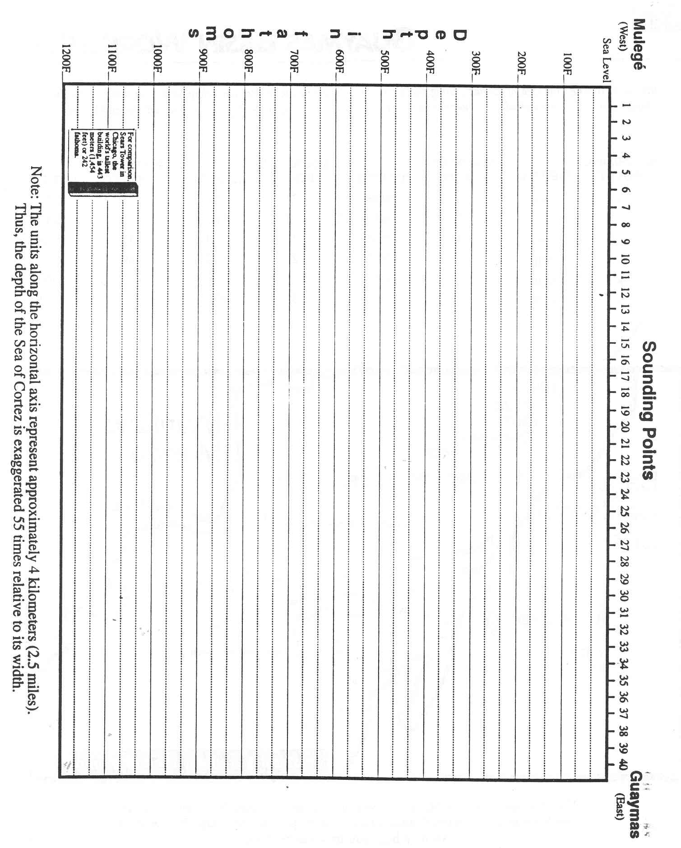

Fill in the Blank Name:______________________________ Class: Date:

Fill in the blanks in these sentences with the word that fits.

1. _____________ is a sediment deposited by currents with the large rocks at the bottom and the fine material at the top.
2. Land deposits found in the deep sea are called______________________________________

3. The continental________________is a zone subdivided into shelf, slope, and rise.

4. The sinking of a broad area of crust without much change is___________________________

5. A unit of__________ equal to about 6 feet is fathom.

6. A trench is a narrow,________, ocean valley.

7 _____ _________ooze is produced from the accumulation of diatoms on the sea floor.
8. Soundings are depth____________ of the ocean basin.

9. Gently sloping zone bordering a continent is the ____________shelf.
10. The rounded, layered lumps found on the ocean floor; contains 20% _______with some iron, nickel, and copper.________________

11. A flat topped, submerged seamount is a ______________

12. The steep_______________angle from the shelf break to the abyssal plain.

13. A device that plunges a hollow tube into bottom sediments to remove a verticle sample is a ______________

14. A___________________volcanic peak of more than 1000m is a seamount.

15. An island arc is a chain of islands formed where plates_______________________

16. _________________ are hills of less than 1000m found on the abyssal plain.

17. A transform fault that is___________________ to a ridge or rise.

18. The flat ocean floor is the_____________________________

19.___________ is the transport of sediments such as rocks, sand, and gravel from land matter out to sea by wind, water, and ice.

20. The rise is a gentle slope formed by the_____________________ of sediments at the base of the slope.

Select your answers from the followinq words:
deposit continental measurements Rafting subsidence margin steep-sided abyssal plain Downward length Turbidite perpendicular guyot Abyssal hills pelagic sediments submarine Diatomaceous corer converge manganese

