2003 Coastal Upwelling in East Central Florida
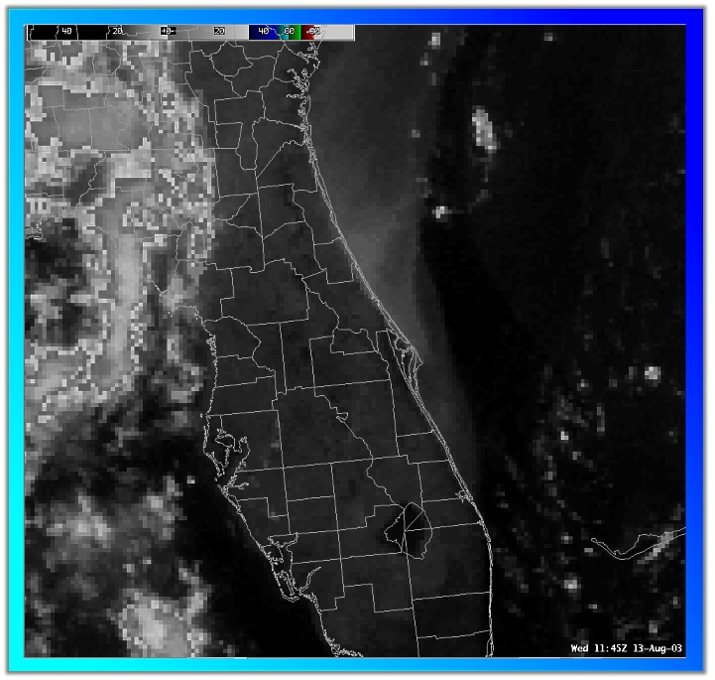  Black & White IR Image from 08-13-03  Click for larger Image | 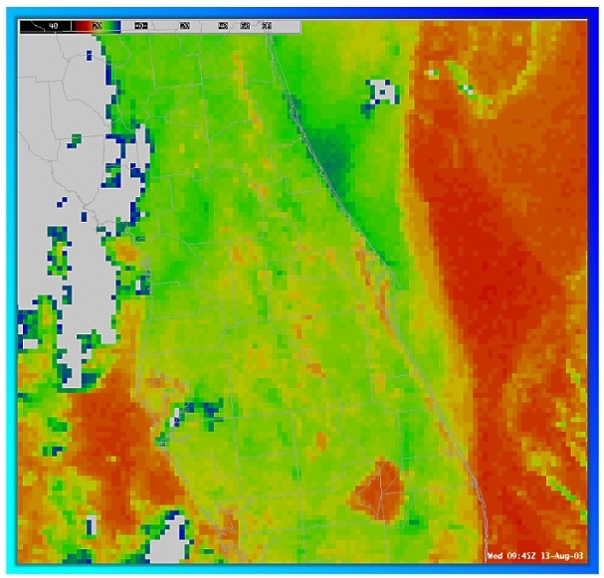  Color IR Image from 08-13-03  Click for larger Image
Description:
During the month of July, 2003 there was a prolonged period of upwelling along the east central Florida coast. Surf temperatures at Daytona Beach were below 70 degrees on numerous days, with some readings in the mid 60s (coolest was 62 degrees). There was not one day when the surf temperature reached 80 degrees! Further south, the cooling was noticed at Port Canaveral/Trident Pier and Fort Pierce, with readings occasionally in the low/mid 70s.
Past Events:
A cursory review of surf temperature data back through 1992 shows that this event has been much more prolonged than in other years. The year with the next most prolonged and intense event was 1994. In 2000, there was also an extended period of cool surf temperatures at Daytona Beach and Jetty Park from late June through early August, but the event was not nearly as extreme. All years had a period with cooler than normal surf temperatures (i.e. below 80 degrees) at Daytona Beach with the exception of 1997. Cocoa Beach/Jetty Park had several years with surf temperatures remaining above 80 for the whole summer (1993, 1995, 1997, 2001)
Upwelling Theory:
The reason upwelling occurs is because of Ekman transport. The flow of most surface currents in the oceans is driven by wind. When wind blows over water, the surface of that water is not pushed directly in front of the wind, but moves at about 45 degrees to the right of the wind's motion in the Northern Hemisphere because of the Coriolis force (which is caused by the rotation of the earth). As one descends in the water, the direction of flow continues to be deflected to the right, until ultimately a three-dimensional spiral is formed vertically in the water. The net transport of water, as explained by Ekman transport, is at an angle of roughly 90 degrees to the direction of the wind. In short, a layer of water near the surface is pulled directly away from the coast - causing cooler deep water to rise and replace it near the shore.
Reason for 2003 Event:
This year has been so extreme because of the strength and persistence of the subtropical high pressure ridge. Surface pressures in the Atlantic have been several millibars greater than average. This has produced a long period where surface winds were predominantly southeast to south. This wind flow, when combined with Ekman transport, will produce a net transport of water away from the coast (which is oriented 340-160 degrees). I have seen some web sites/news articles that show an offshore wind as the cause for upwelling. Based on the Ekman transport principle, this explanation is incorrect. The longtime Official in Charge at the Daytona Beach National Weather Service Office observed upwelling events for many years when the wind flow was southeast.
Ramifications/Proposed Theory:
With cooler sea surface temperatures near shore, the east coast sea breeze should be be stronger than normal at times. This most likely will lead to a more vigorous Atlantic/Gulf sea breeze boundary collision and enhance the strength of storms. I think that the wet season in 1994 also had a lot of severe weather.
Randy Lascody
National Weather Service
Melbourne, FL
Aug. 1, 2003

